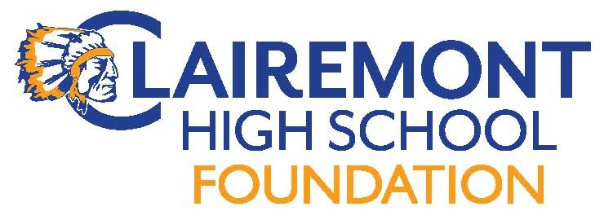
Clairemont High School Foundation
Board Meeting
October 10, 2017
CHS Room 114 (7:30pm)
AGENDA

Call to order:
Introductions:
Approve Meeting Minutes: 9/14/17
Foundation Reports:
Treasurer : Report
Proposed Budget
Fundraising:
Possible Turkey Trot 11/17
Chieftain Pledge
Communications:
Website
Hospitality
Teacher & Staff Appreciation Lunch (5/14)
End of year volunteer/staff appreciation HH 6/1
New Business:
Grant/Sponsorship Requests
Procedures for requests
Upcoming Events:
2/12-15 Have a Heart Campaign
4/14 Spring Fling/Silent Auction
5/14 Teacher/Staff Appreciation Luncheon
Old Business:
Turkey Trot? 11/17
Alumni Outreach Events (Alumni Brunch 10/14(Holly)
Adjourn Meeting:
Next Meeting Date: 11/17 after the Turkey Trot
Meeting dates: (7:30 Rm 114), 1/9 (mixer), 2/13, 4/10, 5/15

