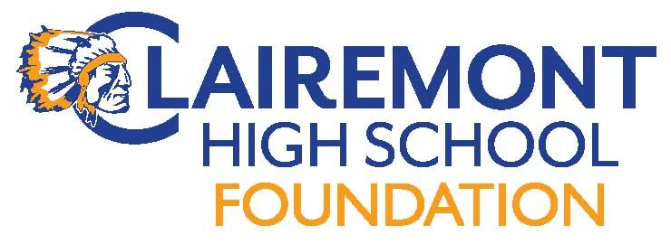
Clairemont High School Foundation
Board Meeting
May 15, 2018
CHS Room 203 (7:00pm)
AGENDA

Call to order:
Introductions:
Approve Meeting Minutes: 4/10/18
Foundation Reports:
Treasurer : Report

Fundraising:
Communications:
Website
Hospitality
Teacher & Staff Appreciation Lunch (5/18) rm 114 (11:30-1:30)
Menu, donations, volunteers
End of year volunteer/staff appreciation HH 6/1
New Business:
Grant/Sponsorship Requests
Tennis Tournament Paperwork? - Friends of CHS Tennis
Special Olympics - pizza
Support of Music and Performance Arts (Michelle Rodriguez)
Foundation Elections
Upcoming Events:
5/14 Teacher/Staff Appreciation Luncheon
Old Business:
4/14 Spring Fling/Silent Auction
Interns: new projects…Wellness
Alumni Outreach Events
Adjourn Meeting:
Next Meeting Date:
Meeting dates:

