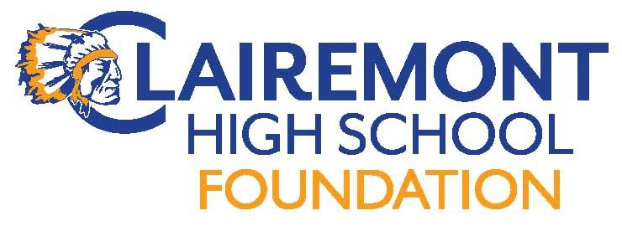

Clairemont High School Foundation
General Assembly Meeting
April 11, 2017
CHS Office 7:30pm
AGENDA
Call to order:
Introductions:
Approve Meeting Minutes: 3/14/17
Foundation Reports:
Treasurer : Report
Fundraising:
Grant writing
Communications:
Website
Hospitality
New Business:
Grant/Sponsorship Requests
Elections
Upcoming Events:
Teacher Luncheon (5/8)

Old Business:
New Intern – George Arroyo
Spring Fling debrief

Adjourn Meeting:
Next Meeting Date: 5/9, 6/13(mixer), 5/8 Staff Appreciation Luncheon

