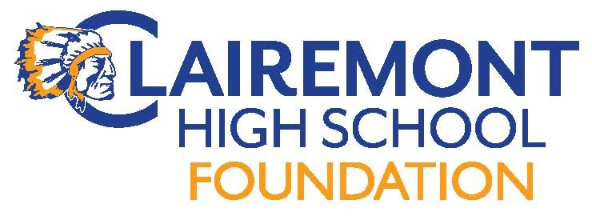
Clairemont High School Foundation
Board Meeting
April 10, 2018
CHS Room 203 (7:00pm)
AGENDA

Call to order:
Introductions:
Approve Meeting Minutes: 3/13/18
Foundation Reports:
Treasurer : Report

Fundraising:
Spring Fling (4/14)
Menu- Italian (Candy Flynn)
Volunteer Coordination
Music selection
Drink Names (Roberson, Manny, Hornbrook, Williams, Victorino, others?)
Communications:
Website
Hospitality
Teacher & Staff Appreciation Lunch (5/14)
End of year volunteer/staff appreciation HH 6/1
New Business:
Grant/Sponsorship Requests
Support of Music and Performance Arts (Michelle Rodriguez)
Foundation Elections
Dissolution of AOB Foundation-money gifted to CHS Foundation (AOB account)
Upcoming Events:
4/14 Spring Fling/Silent Auction
5/14 Teacher/Staff Appreciation Luncheon
Old Business:
Interns: new projects…Wellness
Alumni Outreach Events
Adjourn Meeting:
Next Meeting Date:
Meeting dates: 5/15

