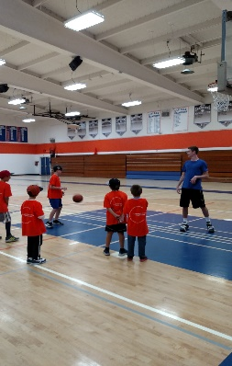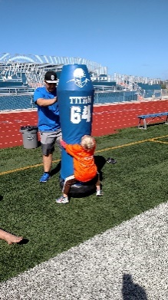

**Camper Info:**

Name:_____________________

Grade:__________

Address:___________________________

Parent Phone #: _____________

Shirt Size: Youth S M L XL

Cluster School attended _______________

Allergies ___________________________

Food Allergies ______________________

**Camp Schedule:**

9:00 Introduction and Stretch

9:30 Session #1

11:00 Lunch Time

11:45 Session #2

1:00 Closing remarks

**Sports Offered:**

**Football, Basketball, Soccer, and Cheer**

*We encourage the* ***Clairemont Cluster Students*** *to come together and meet their future fellow neighborhood Chieftain classmates!*

**Clairemont Camp Details:**

**Date**: Saturday March 23rd- Monday 25th

**Time**: 9:00 am- 1:00 pm

**Ages**: Grade K-8

**Location**: Clairemont High School Football Stadium, Gym, and Indoor field. *Everyday meet in the stadium after checking in with staff.

**What to bring**: Comfortable athletic clothes, and sunscreen both shoes & cleats.*Cleats not required

*Water& Gatorade will be provided

**\*Campers can bring a lunch as an alternative to the Pasta lunch that will be provided for FREE.**

**Cost**: Free (Foundation will also accept donations for the camp)

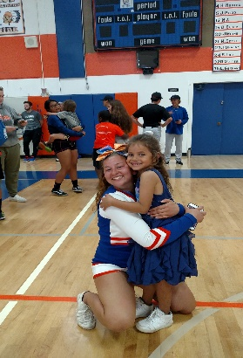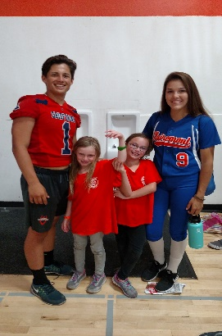

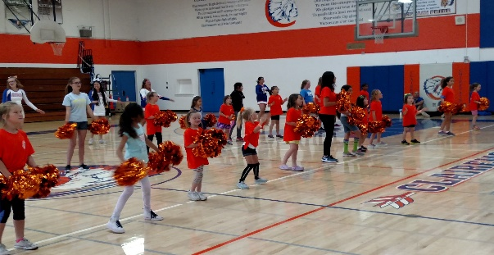

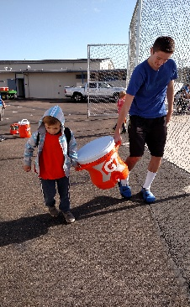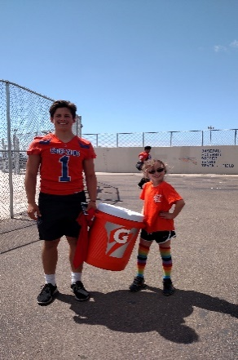

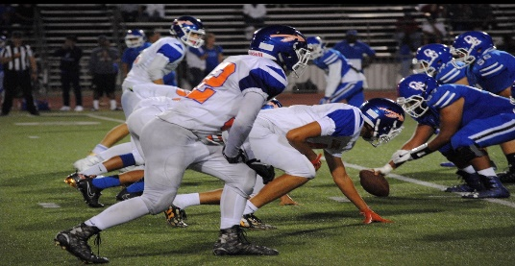

To the best of my knowledge, my son/daughter is in good physical condition and fully able to participate in this camp. I am fully aware of the risks and hazards connected with the participation in this event, including physical injury or even death, and herby elect to allow my son/daughter in said event, knowing that the associated physical activity may be hazardous to my child and his/her property. I VOLUNTARILY ASSUME FULL RESPONSIBILITY FOR ANY RISKS OR LOSS, PROPERTY DAMAGE, OR PERSONAL INJURY, INCLUDING DEATH, that may be sustained by my son/daughter, or loss or damage to property owned by me, or my child, as a result of participation in this camp. I hereby RELEASE, WAIVE, DISCHARGE, AND COVENANT NOT TO SUE, the San Diego Unified School District, Clairemont High School, Clairemont Foundation- Camp or their officers, servants, agents, and employees from any and all liability, claims, demands, actions and causes of action whatsoever arising out of or related to any loss, damage, or injury, including death, that may be sustained by my child, or to any property belonging to my child, while participating in physical activity, or while on or upon the premises where the event is being conducted. *Parents/Guardians who prefer that their child not be photographed or video recorded must notify adults at check in or via email. Schools make every effort to ensure the wishes of the parent/guardian. Please be aware that photographing and video recording by devices such as mobile phones may take place without the knowledge of the coach, camp counselors or Clairemont Foundation Staff.*

Campers Name:_________________________

Parent (Guardian) Name:_________________________

Date:__________________________

Liability Waiver

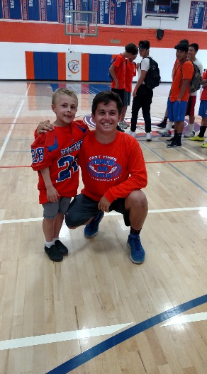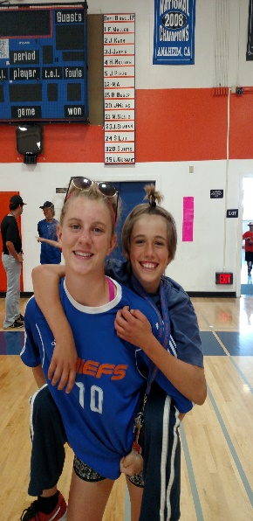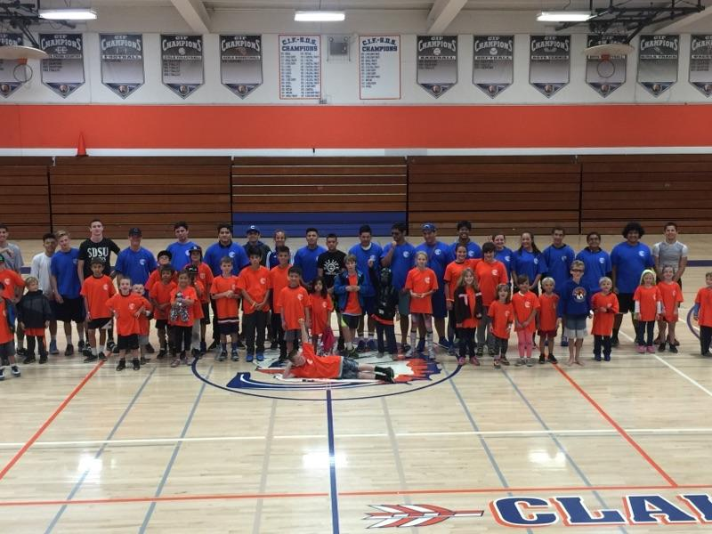

# Clairemont Foundation proudly presents:

# 4th annual Sports Camp for Clairemont Cluster Students: Football, Basketball, Soccer, and Cheer

**FREE!!**

**Saturday-Monday**

**March 23rd- 25th, 2019**

**9:00am-1:00 PM**

4150 Ute Dr.  
San Diego , CA 92117

<http://www.chsfoundation.info/>

Contact: Manny Diaz Athletic Director [mdiaz5@sandi.net](mailto:mdiaz5@sandi.net)

Or

Foundation Member <http://www.chsfoundation.info/>

Campers must have this form filled out or they will not be able to participate.

The Clairemont foundation will accept donations checks made out to: **Clairemont High School Foundation**

Clairemont High School Foundation