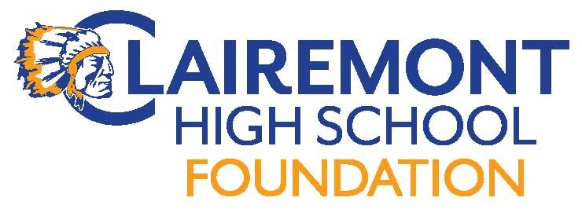
Clairemont High School Foundation
Board Meeting
November 28, 2017
Fast Times (7:30pm)
AGENDA

Call to order:
Introductions:
Approve Meeting Minutes: 10/10/17
Foundation Reports:
Treasurer : Report

Fundraising:
Turkey Trot 11/17-Prize distribution (11/30)
Chieftain Pledge
Communications:
Website
Hospitality
Teacher & Staff Appreciation Lunch (5/14)
End of year volunteer/staff appreciation HH 6/1
New Business:
Grant/Sponsorship Requests
Library
Club Accounts (online donations throughout the year)
Approval of CHS Team Donation Reciept
Approval of Consent Release
Upcoming Events:
2/12-15 Have a Heart Campaign
4/14 Spring Fling/Silent Auction
5/14 Teacher/Staff Appreciation Luncheon
Old Business:
Turkey Trot 11/17
Alumni Outreach Events (Alumni Brunch 10/14(Holly)
Adjourn Meeting:
Next Meeting Date:
Meeting dates: 1/9 (mixer), 2/13, 4/10, 5/15

